MONGODB PROGRAM
use vit
db.Students.insertOne({
id: 101,
name: "John",
department: "CSE",
cgpa: 8.7
})

switched to db vit
db.Students.insertOne({
id: 101,
name: "John",
department: "CSE",
cgpa: 8.7
})
{
acknowledged: true,
insertedId: ObjectId('6a202525b19d9a48b0a60448')
}
db.Students.find()
{
_id: ObjectId('6a202525b19d9a48b0a60448'),
id: 101,
name: 'John',
department: 'CSE',
cgpa: 8.7
}
vit

EXAMPLE 1
import com.mongodb.client.*;
import com.mongodb.client.model.Filters;
import com.mongodb.client.model.Updates;
import org.bson.Document;

public class MongoCRUDExample {

public static void main(String[] args) {

// Connect to MongoDB
MongoClient mongoClient = MongoClients.create("mongodb://localhost:27017");

// Access database
MongoDatabase database = mongoClient.getDatabase("vit");

// Access collection
MongoCollection<Document> collection =
database.getCollection("Students");

// ==========================
// CREATE (Insert)
// ==========================
Document student = new Document("id", 101)
.append("name", "John")
.append("department", "CSE")
.append("cgpa", 8.7);

collection.insertOne(student);
System.out.println("Document Inserted Successfully");

// ==========================
// READ (Find)
// ==========================
System.out.println("\nStudent Records:");

FindIterable<Document> students = collection.find();

for (Document doc : students) {
System.out.println(doc.toJson());
}

// ==========================
// UPDATE
// ==========================
collection.updateOne(
Filters.eq("id", 101),
Updates.set("cgpa", 9.2)
);

System.out.println("\nDocument Updated Successfully");

// ==========================
// READ Updated Record
// ==========================
Document updatedStudent =
collection.find(Filters.eq("id", 101)).first();

System.out.println("\nUpdated Record:");
System.out.println(updatedStudent.toJson());

// ==========================
// DELETE
// ==========================
collection.deleteOne(Filters.eq("id", 101));

System.out.println("\nDocument Deleted Successfully");

// Close connection
mongoClient.close();
}
}

OUTPUT:
Document Inserted Successfully
Student Records:
{"_id": {"$oid": "6a20254dacc1354a2cbc2ed7"}, "id": 101, "name": "John", "department": "CSE", "cgpa": 8.7}

Document Updated Successfully

Updated Record:
{"_id": {"$oid": "6a20254dacc1354a2cbc2ed7"}, "id": 101, "name": "John", "department": "CSE", "cgpa": 9.2}

Document Deleted Successfully
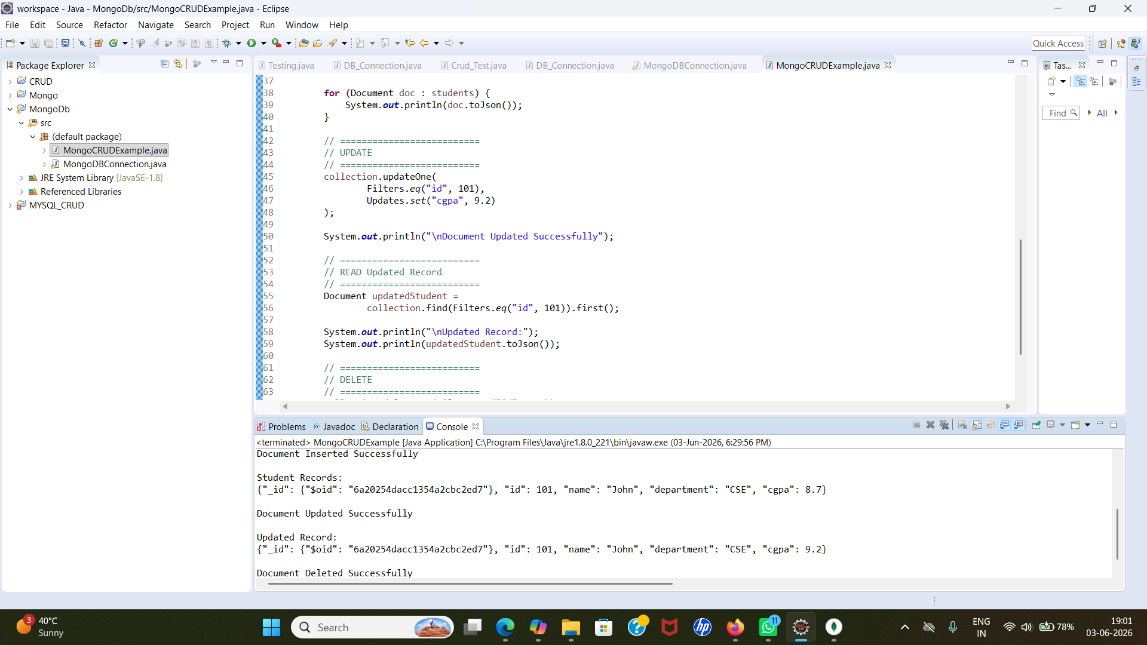

EXAMPLE 2
import com.mongodb.client.*;
import com.mongodb.client.model.Filters;
import com.mongodb.client.model.Updates;
import org.bson.Document;

import java.util.Arrays;

public class MongoCRUDExample {

public static void main(String[] args) {

// Connect to MongoDB
MongoClient mongoClient = MongoClients.create("mongodb://localhost:27017");

// Access database
MongoDatabase database = mongoClient.getDatabase("vit");

// Access collection
MongoCollection<Document> collection = database.getCollection("Students");

// ==========================
// CREATE (InsertMany)
// ==========================
Document s1 = new Document("id", 101).append("name", "John").append("department", "CSE").append("cgpa", 8.7);
Document s2 = new Document("id", 102).append("name", "Alice").append("department", "ECE").append("cgpa", 7.9);
Document s3 = new Document("id", 103).append("name", "Bob").append("department", "ME").append("cgpa", 8.2);

collection.insertMany(Arrays.asList(s1, s2, s3));
System.out.println("Documents Inserted Successfully");

// ==========================
// READ (Find All)
// ==========================
System.out.println("\nStudent Records:");
FindIterable<Document> students = collection.find();
for (Document doc : collection.find()) {
System.out.println(doc.toJson());
}

// ==========================
// UPDATE (UpdateMany)
// ==========================
collection.updateMany(
Filters.gt("cgpa", 8.0),
Updates.set("status", "Excellent")
);
System.out.println("\nDocuments Updated Successfully");

// ==========================
// READ Updated Records
// ==========================
System.out.println("\nUpdated Records:");
for (Document doc : collection.find()) {
System.out.println(doc.toJson());
}

// ==========================
// DELETE (DeleteMany)
// ==========================
collection.deleteMany(Filters.lt("cgpa", 8.0));
System.out.println("\nDocuments Deleted Successfully");

// ==========================
// READ Remaining Records
// ==========================
System.out.println("\nRemaining Records:");
for (Document doc : collection.find()) {
System.out.println(doc.toJson());
}

// Close connection
mongoClient.close();
}
}

OUTPUT:
Documents Inserted Successfully

Student Records:
{"_id": {"$oid": "6a203508d6206e1b232d416f"}, "id": 101, "name": "John", "department": "CSE", "cgpa": 8.7, "status": "Excellent"}
{"_id": {"$oid": "6a2035972ebb433c8408a0fd"}, "id": 101, "name": "John", "department": "CSE", "cgpa": 8.7, "status": "Excellent"}
{"_id": {"$oid": "6a2035972ebb433c8408a0ff"}, "id": 103, "name": "Bob", "department": "ME", "cgpa": 8.2, "status": "Excellent"}
{"_id": {"$oid": "6a20442268fd9f7f1eb8a87f"}, "id": 101, "name": "John", "department": "CSE", "cgpa": 8.7}
{"_id": {"$oid": "6a20442268fd9f7f1eb8a880"}, "id": 102, "name": "Alice", "department": "ECE", "cgpa": 7.9}
{"_id": {"$oid": "6a20442268fd9f7f1eb8a881"}, "id": 103, "name": "Bob", "department": "ME", "cgpa": 8.2}

Documents Updated Successfully

Updated Records:
{"_id": {"$oid": "6a203508d6206e1b232d416f"}, "id": 101, "name": "John", "department": "CSE", "cgpa": 8.7, "status": "Excellent"}
{"_id": {"$oid": "6a2035972ebb433c8408a0fd"}, "id": 101, "name": "John", "department": "CSE", "cgpa": 8.7, "status": "Excellent"}
{"_id": {"$oid": "6a2035972ebb433c8408a0ff"}, "id": 103, "name": "Bob", "department": "ME", "cgpa": 8.2, "status": "Excellent"}
{"_id": {"$oid": "6a20442268fd9f7f1eb8a87f"}, "id": 101, "name": "John", "department": "CSE", "cgpa": 8.7, "status": "Excellent"}
{"_id": {"$oid": "6a20442268fd9f7f1eb8a880"}, "id": 102, "name": "Alice", "department": "ECE", "cgpa": 7.9}
{"_id": {"$oid": "6a20442268fd9f7f1eb8a881"}, "id": 103, "name": "Bob", "department": "ME", "cgpa": 8.2, "status": "Excellent"}

Documents Deleted Successfully

Remaining Records:
{"_id": {"$oid": "6a203508d6206e1b232d416f"}, "id": 101, "name": "John", "department": "CSE", "cgpa": 8.7, "status": "Excellent"}
{"_id": {"$oid": "6a2035972ebb433c8408a0fd"}, "id": 101, "name": "John", "department": "CSE", "cgpa": 8.7, "status": "Excellent"}
{"_id": {"$oid": "6a2035972ebb433c8408a0ff"}, "id": 103, "name": "Bob", "department": "ME", "cgpa": 8.2, "status": "Excellent"}
{"_id": {"$oid": "6a20442268fd9f7f1eb8a87f"}, "id": 101, "name": "John", "department": "CSE", "cgpa": 8.7, "status": "Excellent"}
{"_id": {"$oid": "6a20442268fd9f7f1eb8a881"}, "id": 103, "name": "Bob", "department": "ME", "cgpa": 8.2, "status": "Excellent"}

